Student Management System

// Create Student Table

1) CREATE TABLE students(
id INT AUTO_INCREMENT PRIMARY KEY,
name VARCHAR(25),
age INT(50),
course VARCHAR(25),
email VARCHAR(25),
contact_number INT(11)
)
Output:
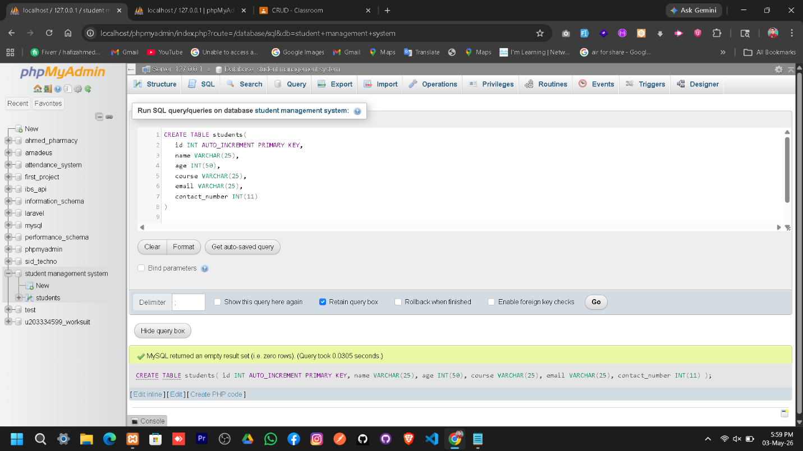

// INSERT 10 Student Data

2) INSERT INTO students (id, name, age, course, email, contact_number)
VALUES
('', 'Ahmed', 21, 'PHP & MySQL', 'ahmed123@gmail.com', '1234567890'),
('', 'Anas', 22, 'Laravel', 'anas@gmail.com', '03001234567'),
('', 'Sara', 20, 'Web Development', 'sara@gmail.com', '03111234567'),
('', 'Usman', 23, 'Python', 'usman@gmail.com', '03221234567'),
('', 'Ayesha', 19, 'Graphic Design', 'ayesha@gmail.com', '03331234567'),
('', 'Bilal', 24, 'JavaScript', 'bilal@gmail.com', '03441234567'),
('', 'Hina', 21, 'UI/UX Design', 'hina@gmail.com', '03551234567'),
('', 'Zain', 22, 'React JS', 'zain@gmail.com', '03661234567'),
('', 'Fatima', 20, 'Digital Marketing', 'fatima@gmail.com', '03771234567'),
('', 'Hamza', 25, 'Data Science', 'hamza@gmail.com', '03881234567');
Output:
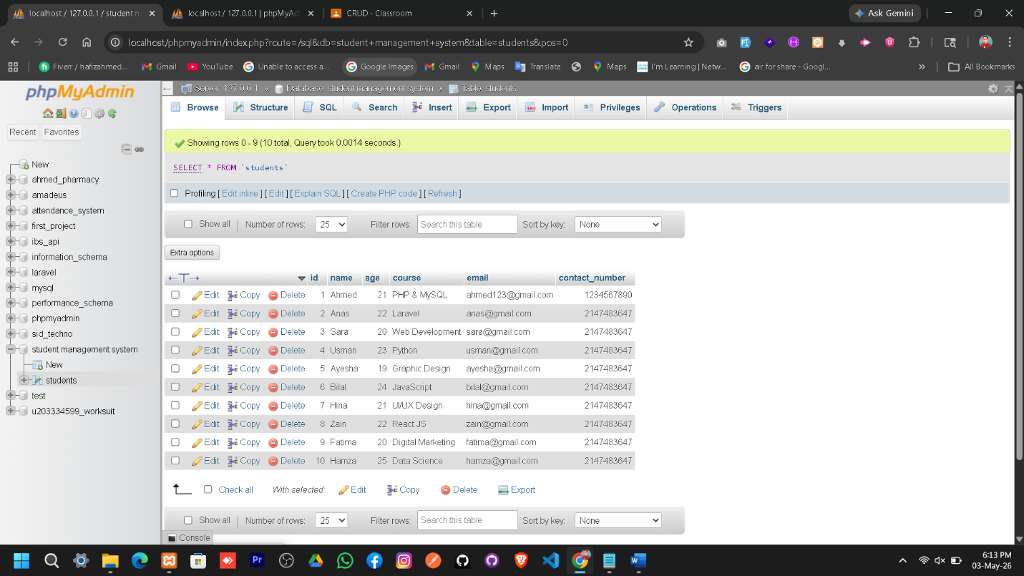

// GET Students Table
- SELECT * FROM students
Output:
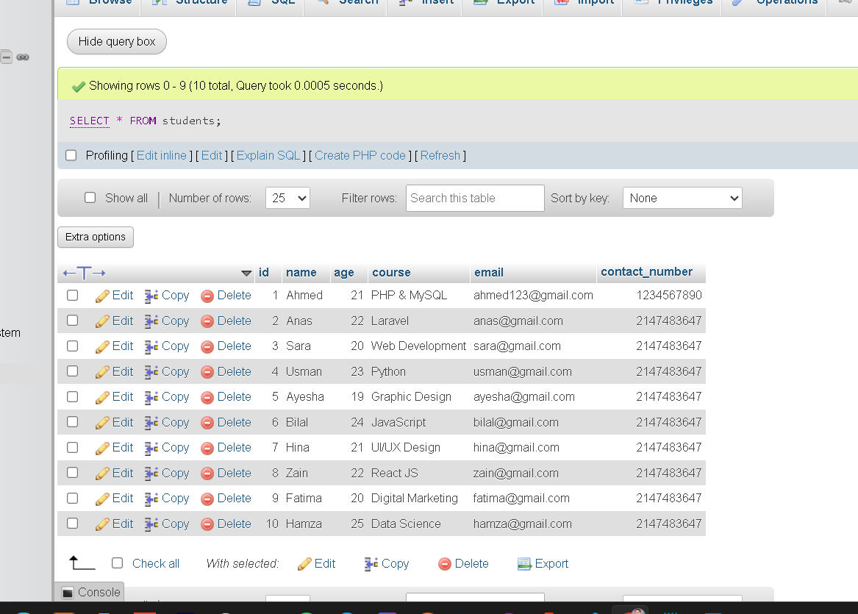

// GET Students Table
- SELECT * FROM students WHERE age > 20
Output: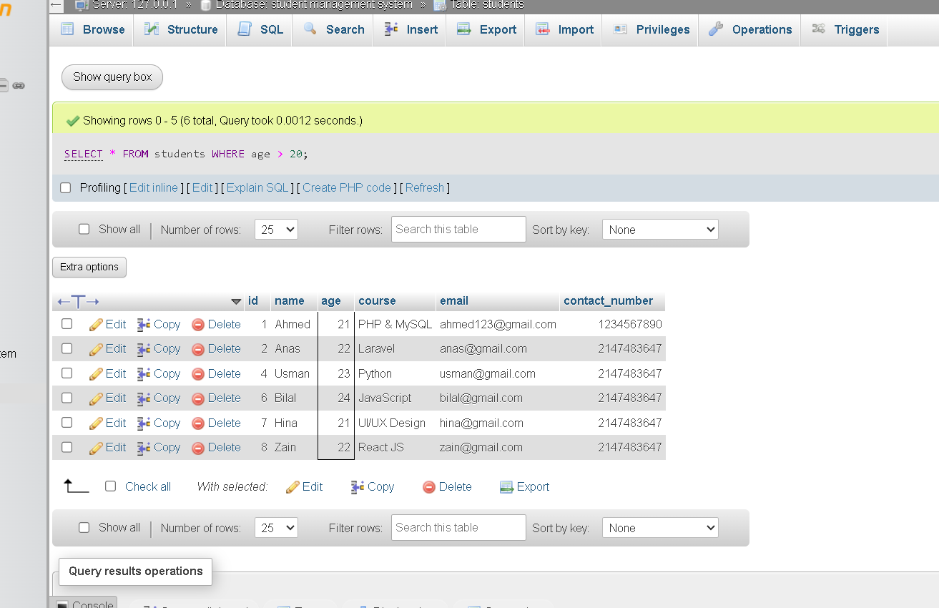

// 1Students Course Update
5) Update students set course='HTML' WHERE id=9
SELECT * FROM `students` WHERE id=9
Output: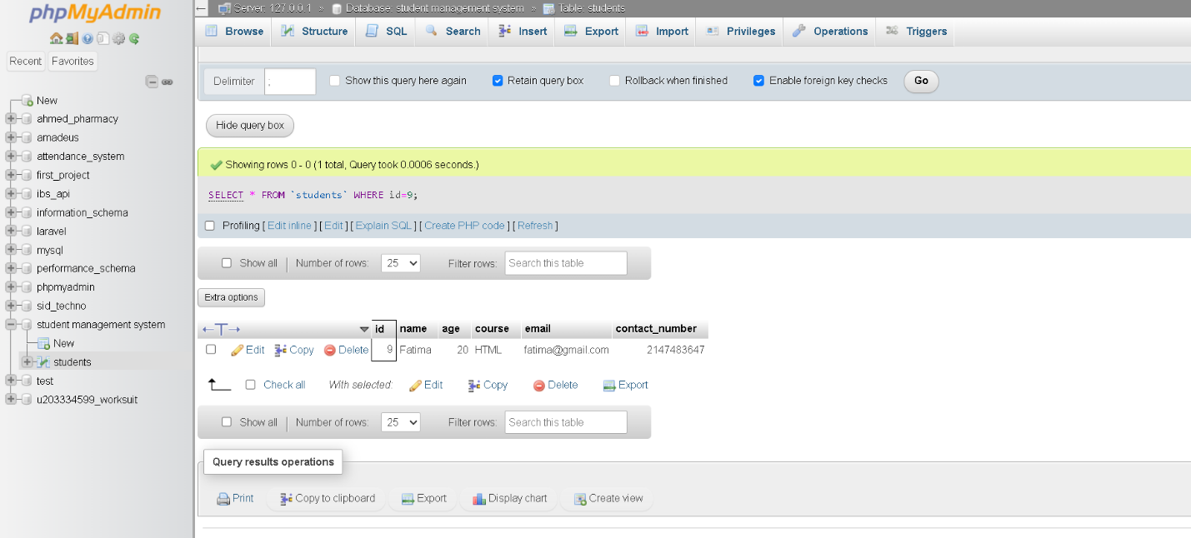

// 1Students Age Update
6) UPDATE students set age=23 WHERE id=10
SELECT * FROM `students` WHERE id=10
Output:
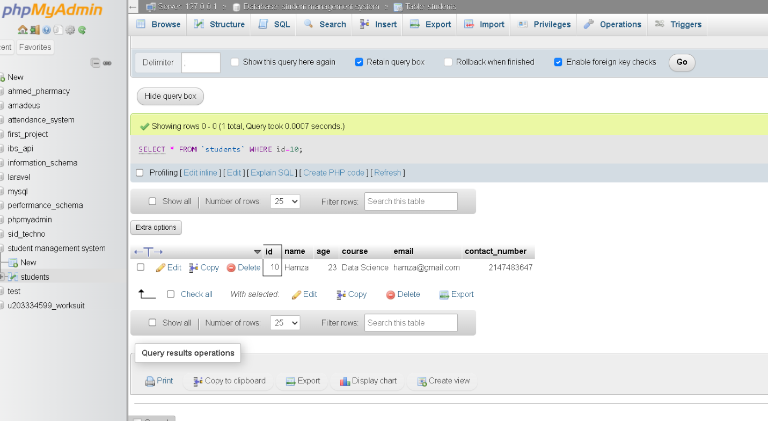

// 1Students Delete
7) DELETE FROM students WHERE id=10
SELECT * FROM `students`
Output:
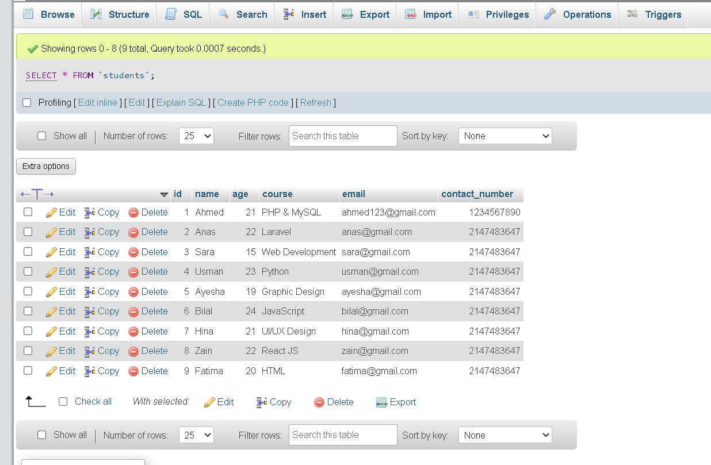

// Students Delete Age < 18
8) DELETE FROM students WHERE age < 18
SELECT * FROM `students`
Output:
